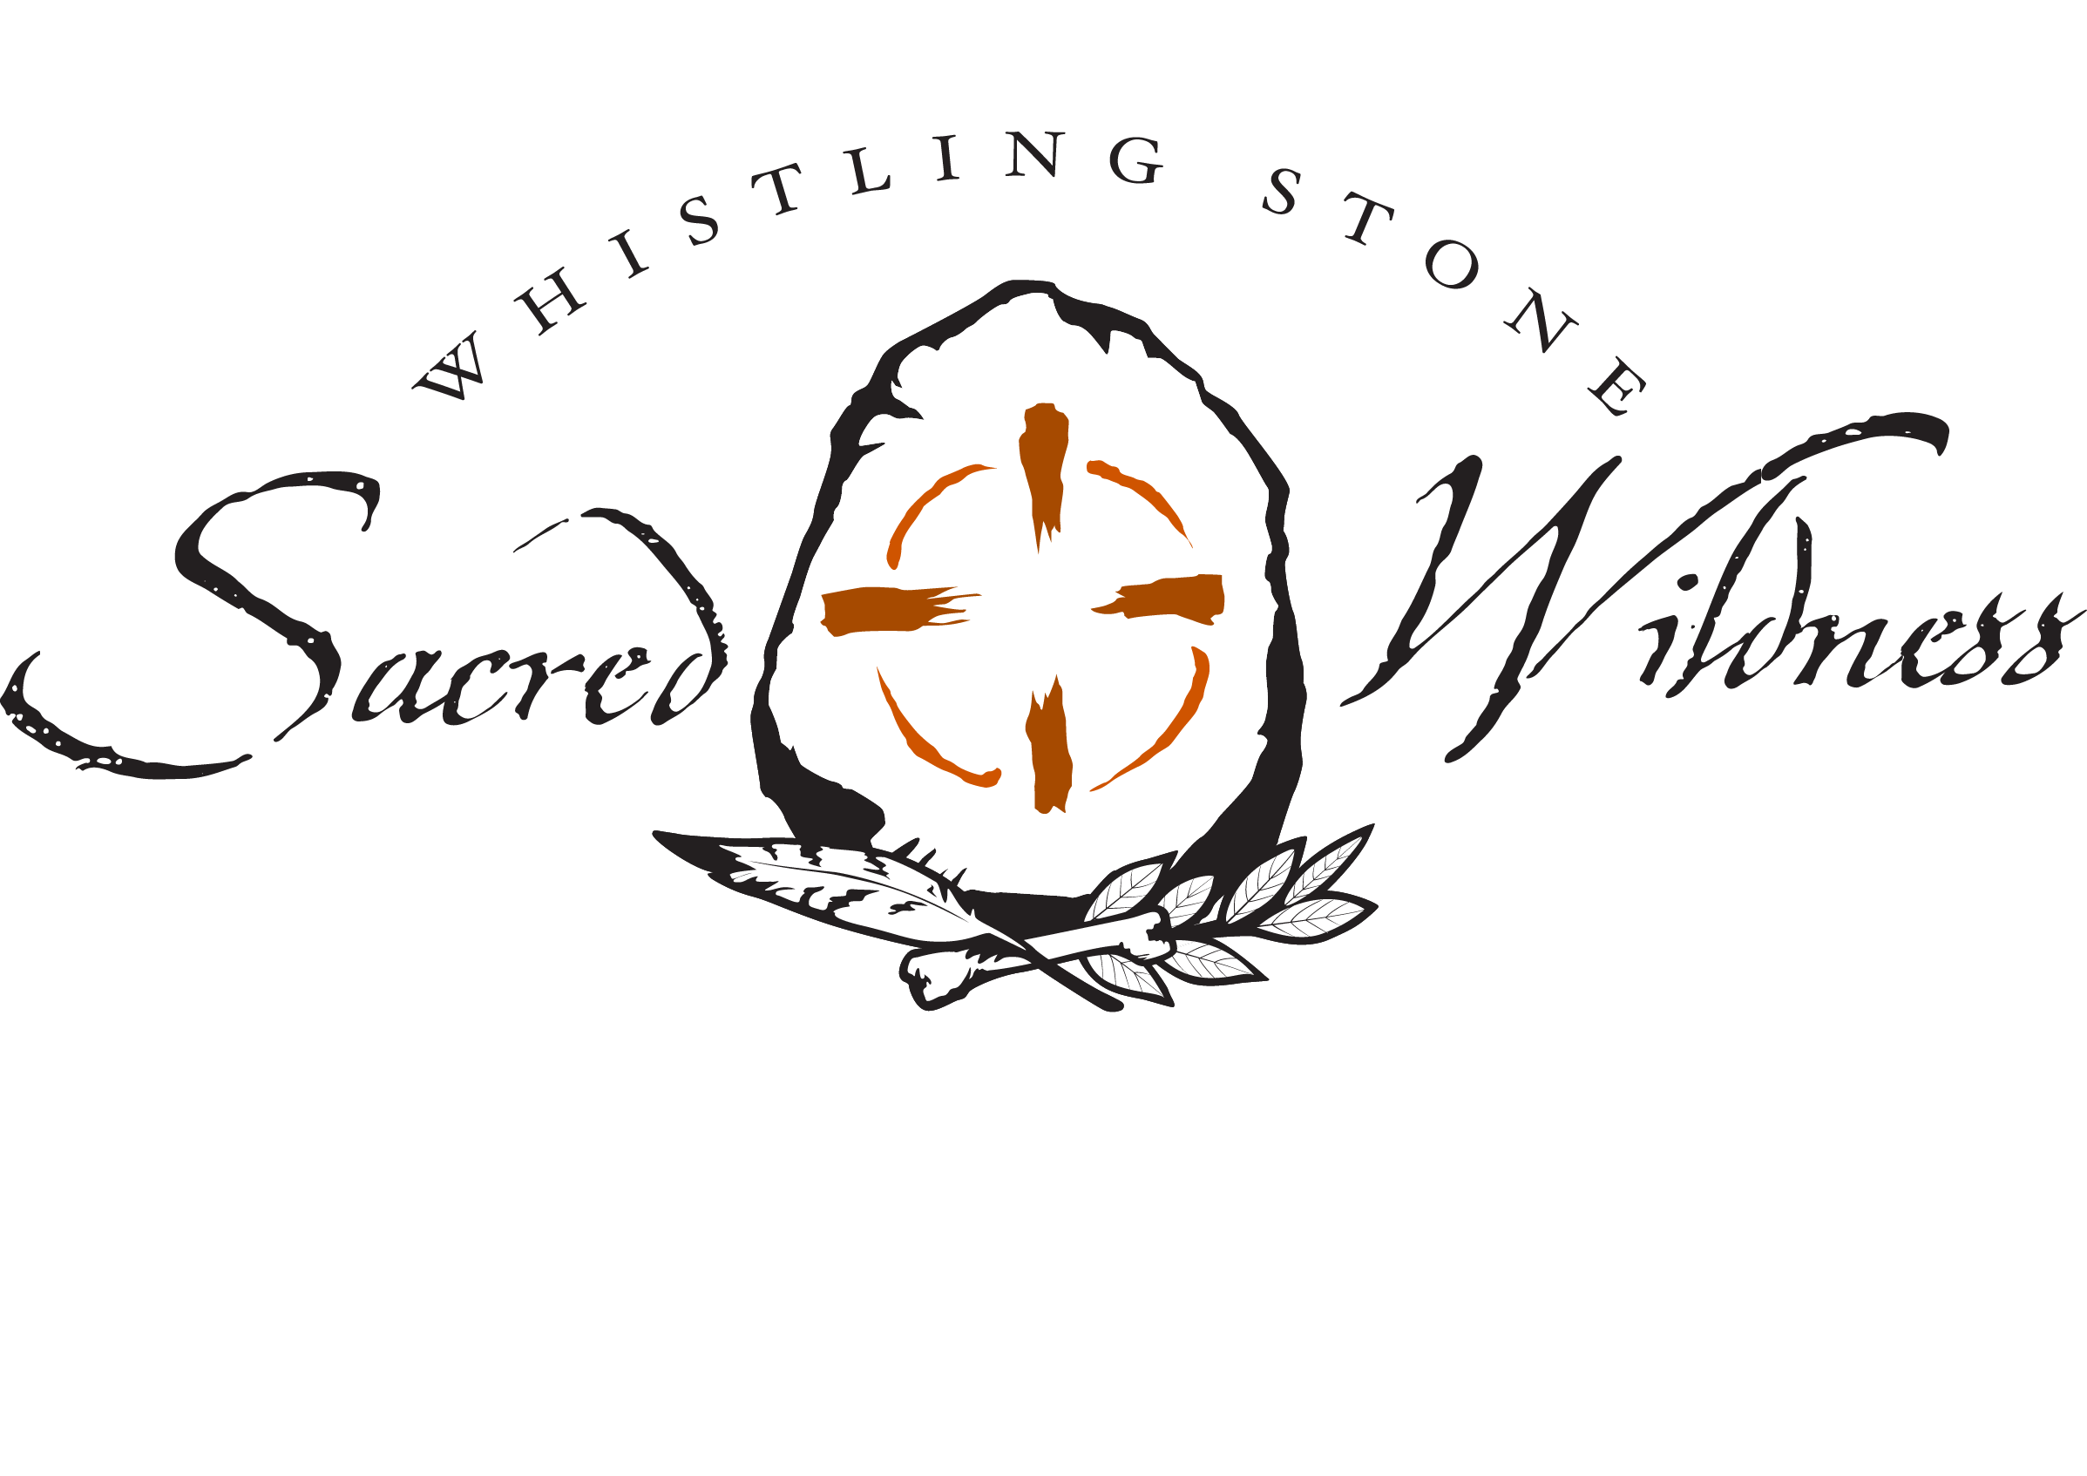
Sacred Wildness – Wild Soul Wilderness Journey

March 22-26, 2017 Gila Wilderness, NM

Please complete this Registration form and email to Darcey at sacredwildness@gmail.com
*Click in each section and type. It will automatically expand for additional space if needed.
Name:
Email:
Telephone:

Any Dietary Restrictions, Allergies, Physical injuries or trouble spots to be aware of?

LIst any/all Medical Conditions and Medications you are currently taking.

What appeals to you, speaks to you and/or what are your reason(s) for joining me at Wild Soul Journey? Anything specific you are looking to gain personally, spiritually?

Do you have any prior experience in Shamanic practices & journeying, ceremony/personal ritual?
If Yes, please describe:

We will be doing healing & shadow work in relation to nature practices and ceremony. Is there anything you can share with me now as to what you may need to best assist you? Personal healing or issues?

What is your experience with outdoor skills and earth medicine skills, nature awareness?

Do you have any questions that you would like answered about practices, skills, and activities pertaining to Wild Soul Journey

What is your experience with personal healing work and ceremony?

What personal gifts/skills/offerings do you bring that you can share with the group?

Please direct all questions and concerns about Wild Soul Wilderness Journey to sacredwildness@gmail.com

Bottom of Form

