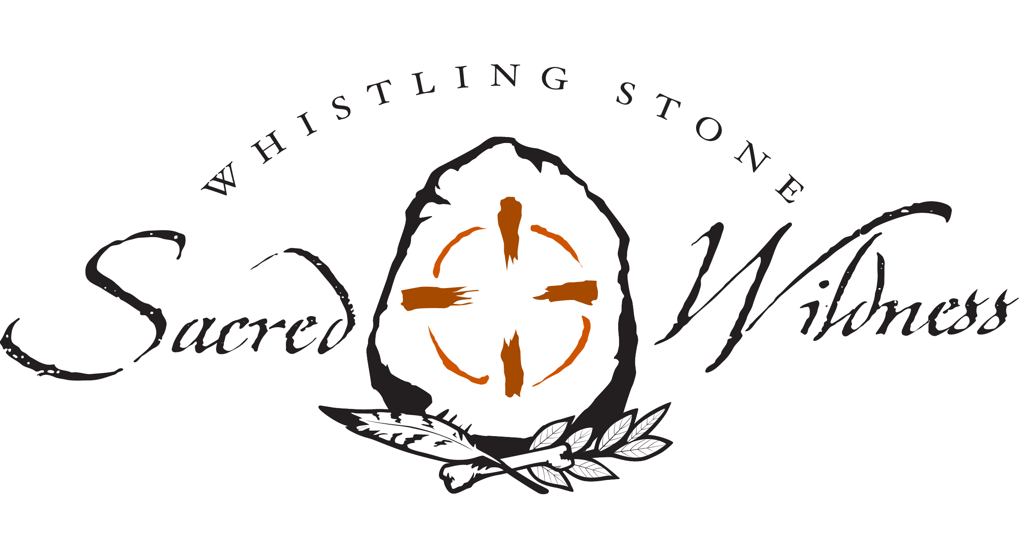
Dear one, Thank you for your courage and willingness to take this journey of discovery and rewinding the soul and heart with me this year! It is my sincere hope that this work enriches your life, your spiritual practice, and your connection with the sacred wild of the Earth and all her wisdom. We are at the turning point in our culture and history- with one world seemingly crashing in around us, and another yet barely a glimmer of hope in the hearts of many, who see, feel and dream another way of being on this planet we call home.
Wild Soul | Sacred Life Mentorship Application

Please WRITE A LETTER OF INTENTION about why you want to join this mentorship at this time, and answer the following questions in your letter. (please do not only answer the questions, spend some time and thought on this, as a process it will help you clarify your needs/wants and challenges) and It will help me get to know you and your journey, and help me understand how best to share this work with you. - Darcey Blue

What drew you to undertake this work/path at this time in your life?

What is your current relationship to wilderness/nature?

What is your current relationship to the sacred/spirit in your life?

What current practices do you work with for your own growth, balance and connection?

What does the soul mean to you?

Do you feel you have a calling/purpose for your life at this time?

What do you feel are your gifts and natural inclinations?

What is your earliest memory of feeling connected to wilderness/nature? And to the sacred/spirit?

What challenges are you facing in your personal, emotional, soul, spiritual life right now?

How can you see yourself working with and through these challenges? What resources, support and guidance do you feel you need?

How much time do you spend in nature currently?

Name three changes or developments you would like to see in your life from this work?

What are three intentions you have for yourself over the course of this work ? (Note, these are not goals to accomplish, but guiding energies for yourself… i.e. commitment to opening the heart, allowing myself to feel and face fear, nourishing myself deeply…etc.)

What is most important to you about this work right now?

Anything else you want to share about previous experience, hopes, desires, fears, gifts etc.

